## Copying a file to the hand-in folder

1. Open My Documents.  
   Navigate this window to the file you want to hand in.  
   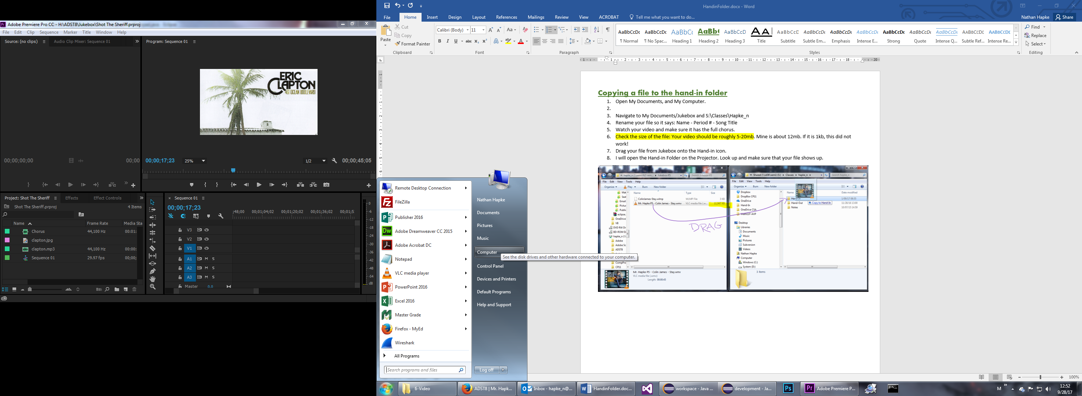
2. Rename your file so it has your Name in it.
3. Open My Computer and Navigate to:  
   S: (Shared drive) /Classes / your_teacher (Mine is hapke_n)  
    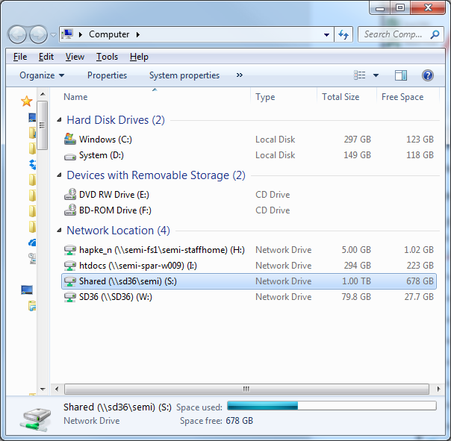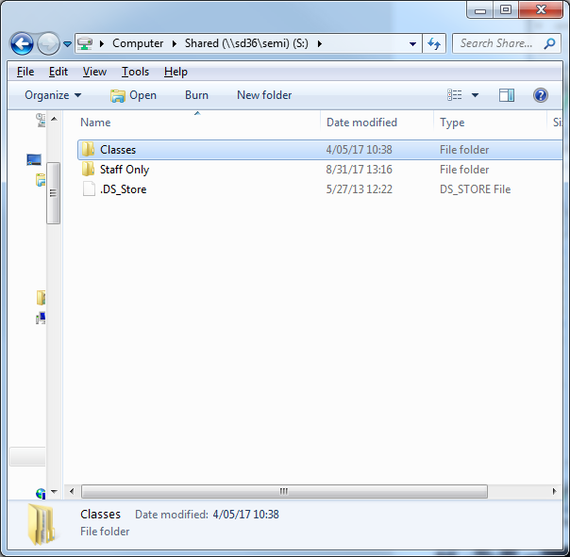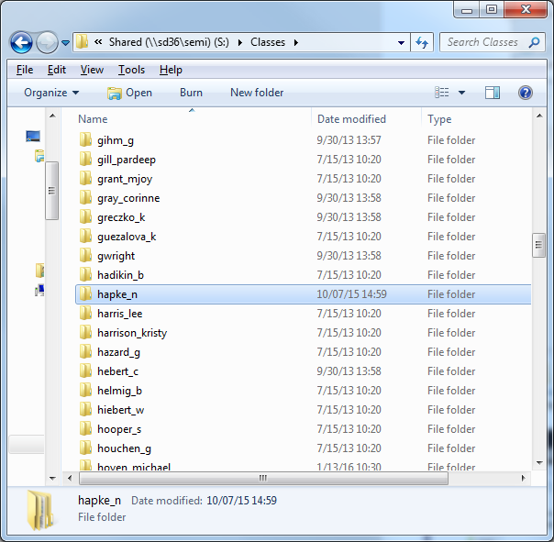
4. Drag your file from the My Documents window onto the Hand-in icon.

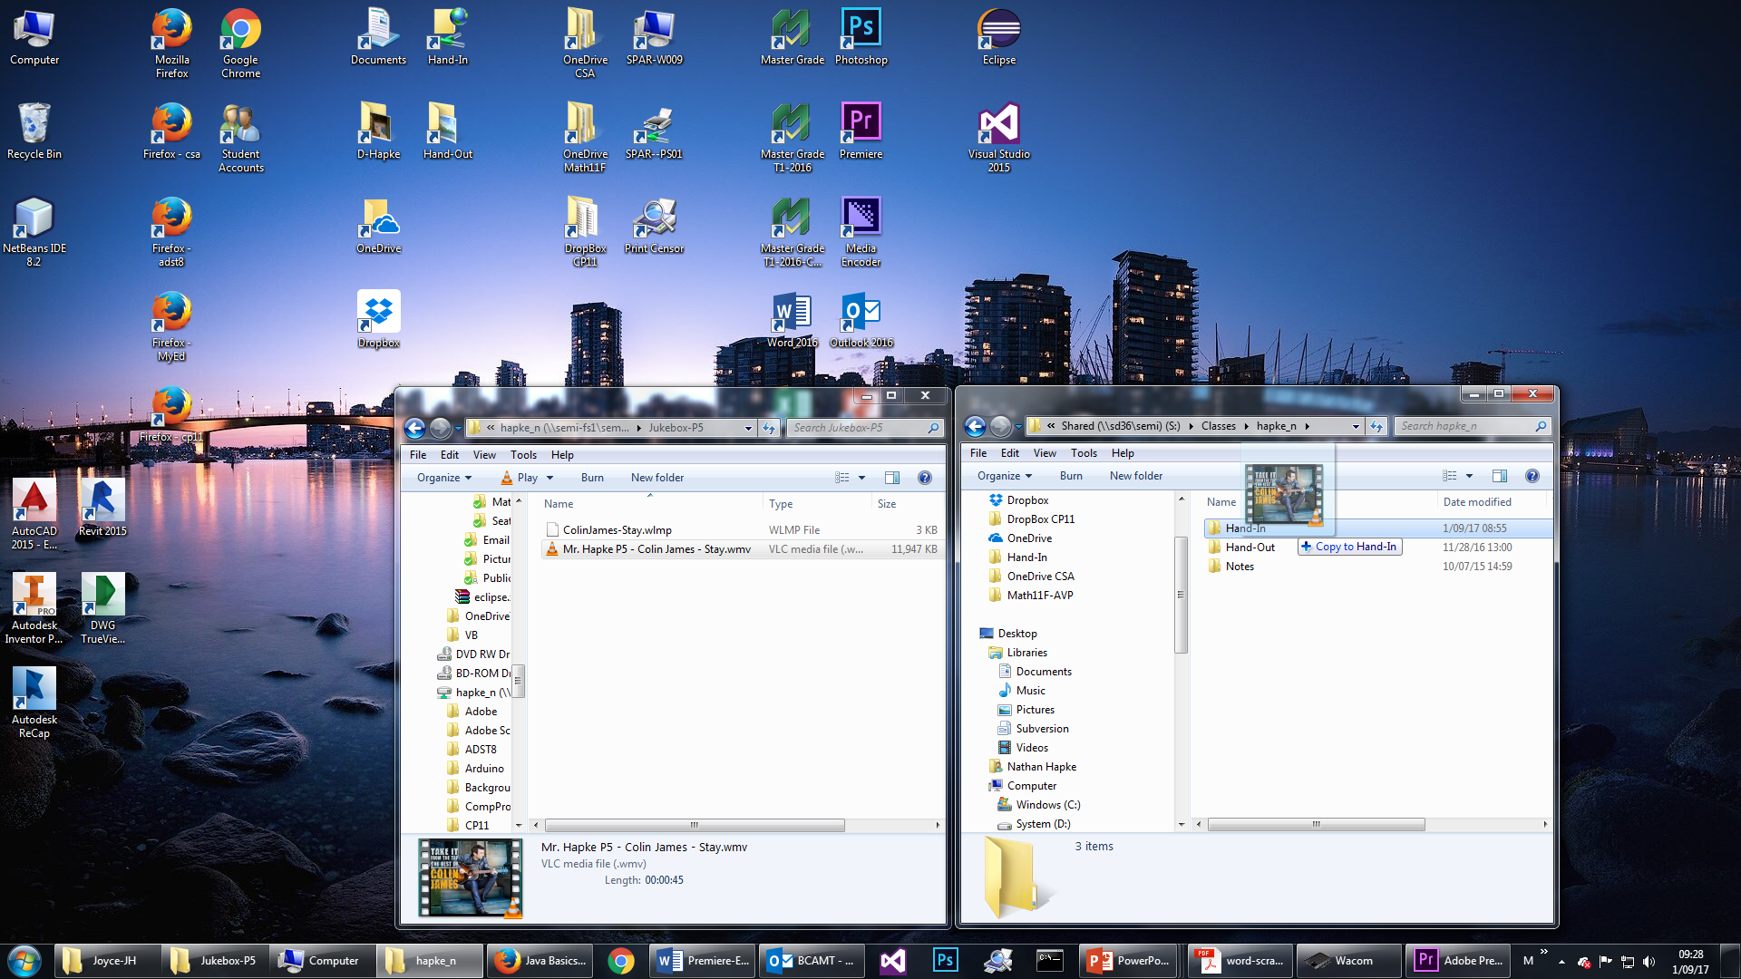

DRAG

1. I will open the Hand-in Folder on the Projector. Look and make sure that your file shows up.