Assignment 1: About Me

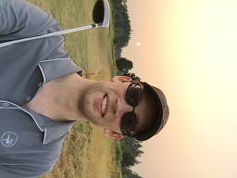**Open Microsoft Word, and write me a page covering these points.**

The writing should be easy to read, (sentence form) without any spelling errors.

Write About The Following Topics:

* Your name and a recent picture of you at the top of the page.   
  I am trying to learn your names, so the photo is necessary!
* Tell me about your family (parents, brothers, sisters, pets, etc.)
* Find a picture of a street you grew up on and tell me a couple of your favourite memories/stories. The stories could be recent or a long time ago. Either is fine!
  + If you can’t find the exact location, then somewhere close will be fine. If you have lived in a few different places, you may pick any one of them.
  + 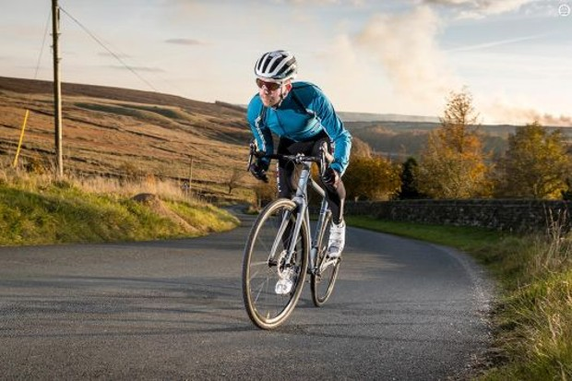Use Google Maps for this. Consider using street view.   
    (drag the orange guy icon onto the map).
  + You can take a screenshot with Snipping Tool (from the Start menu), and then paste into word (CTRL+V)
* Tell me a hobby or two of yours.
  + Include at least one image.
  + Example: I enjoy cycling and photography.
* What is your favourite and least favourite type of technology?
  + Even someone who likes technology must have a least favourite!
  + Explain both of these with at least 2 sentences each.
  + Example: I think self-driving cars are stupid and dangerous.

Rubric (Subject to Change)

**ADST8 - About Me Assignment** Name: Total: _____ / 6

|  |  |
| --- | --- |
| Category | Criteria |
| You | Personal & Family Info (Brothers/Sisters/Pets/etc.)  A photo of you (Selfie/Group Pic etc.)   * Recent * Shows your face |
| Street You Grew Up On | A fun story or two  Screenshot from Google Maps/Street view |
| Hobbies | Info  At least one image |
| Technology | Favourite + Least Favourite  Explanation |
| Images | At least 3 overall  Sizing makes sense & Related to the text context  Toolbars/unnecessary stuff cropped out  Wrap Text:   * Text flows around in a nice way * Don’t have half of the text on either side of the image (hard to read) |