12 Months of Fun!

# D:\Hapke\Dropbox\CSA\Word-v2\yllas.jpgIntroduction

According to WorldAtlas.com there are between 189 and 196 independent countries in the world today. The final number depends on how you count them. For example, Taiwan is sometimes considered a country, or sometimes considered a province of China. For the purposes of this assignment, if you can justify it as an independent country to me, then it counts. On October 10/2017, the province of Catalonia declared independence from Spain, and then 8 seconds later postponed it indefinitely!? Because their independence has been postponed, I am not considering Catalonia a country.

From NYTimes App

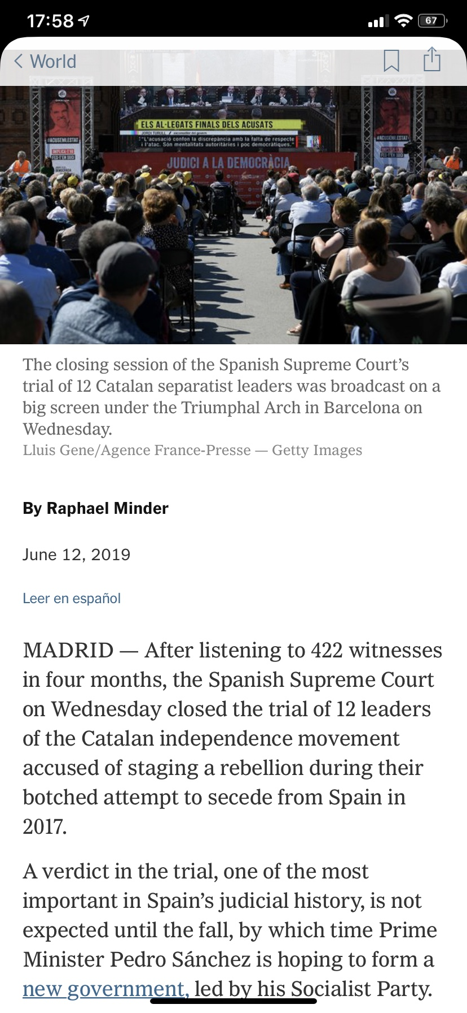

**Update** (June 2019) It was considered a botched attempt, and they were put on trial at the Supreme Court!

Google maps will be projected onto the white board at the front of the room. You must choose a country you have never visited. Cross off your country of choice using the white board marker.

# Content

Make a tourist brochure with 12 activities to do in your country. One for each month of the year. They do not have to all be in the same city.

1. Month
2. An activity you could do in that month.
3. A picture of that activity
4. Climate Info
   * Average high temperature
   * Average low temperature
   * Average Amount of Precipitation (mm or inches)  
     You can use the capital city’s climate.

# Example Activities

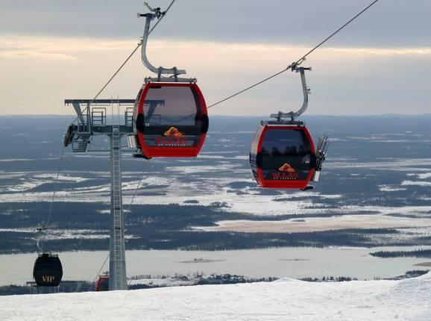Each activity’s description should be 2-3 sentences long.

January (in Finland)

Go skiing at Ylläs Ski Resort, which is near the village of Ylläsjärvi. It has an elevation difference of 518m, which is the largest difference in all of Finland. The peak is 718 m (2356 ft)

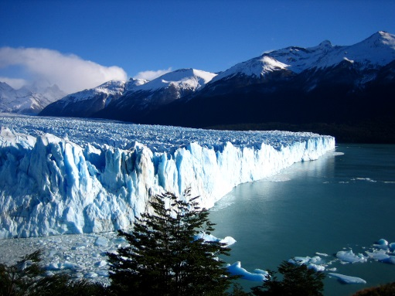February (in Argentina)

Visit the Perito Moreno Glacier, which is between the villages of Puerto Bandera and El Calafate. There are boat tours from El Calafate. The glacier is 30km in length, and 5km wide!

# Suggested Websites

* LonelyPlanet.com
* ClimaTemps.com
* TripAdvisor.ca
* LatLong.net
* TimeAndDate.com

# How to Begin

1. Pick your country.  
   No Canada / USA / North Korea / Country you’ve been to  
   I strongly discourage poor, war-torn countries, because finding fun tourist activities is hard!
2. Collect some activity ideas. (see below)
   1. Create 12 months folder.
   2. Find fun activities and good pictures to go with them
   3. Open a blank word doc for brainstorming.   
      Save your brainstorming doc in this folder.
3. Next class we will:
   1. Look at the paper formatting for brochures. Bring a pencil/pen to write with!
   2. Set up the document formatting together in Word.

# Collecting Activities

Open My Documents/ADST8. Create a folder called “12 Months”.

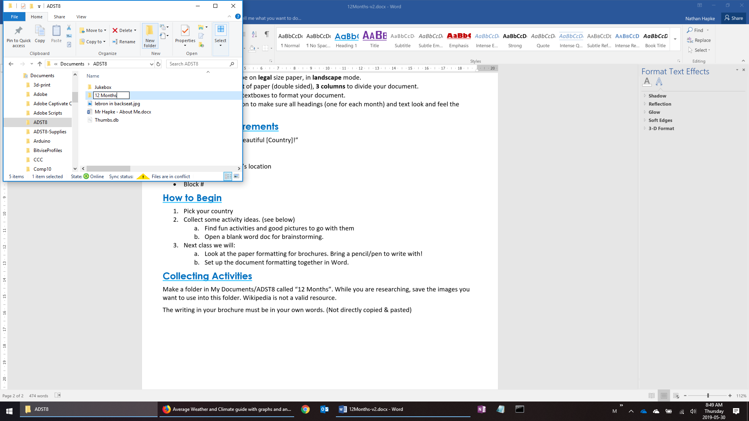

While you are researching, save the images you want to use into this folder. Wikipedia is not a valid resource.

The writing in your brochure must be in your own words. (Not directly copied & pasted!)

# Document Format

* Microsoft Word
* Your document will be on **legal** size paper, in **landscape** mode.
* You must use **1 sheet** of paper (double sided), **3 columns** to divide your document.
* You must NOT use textboxes to format your document.
* Use the Styles function to make sure all headings (one for each month) and text look and feel the same.

# Front Cover Requirements

* “Welcome to/Visit/Beautiful [Country]!”
* Country Flag
* Map of Country  
  Show the capital city’s location
* Name
* Block #