Computers 9 – Website Assignment

You are to create a web page using WordPress.com. We will use this site for various purposes throughout the semester.

When you create your site, create a something.wordpress.com page, with a free account. I don’t expect you to pay for this.

You need to input a real e-mail address when creating your site. It sends you a confirmation e-mail that you need to click confirm in. If you do not have a personal e-mail address, you can receive mail at *<username>*@surreyschools.ca. You can check that account by going to <https://mail.surreyschools.ca/>.

After you create your account, choose a theme. You must choose a theme which has a menu bar at the top. Shoreditch, Rebalance, Rowling, Escutcheon and Toujours are good choices.

Your web site needs the following pages (pages, not posts!) and content:

Home Page:

* This page should explain what the site is about and why it was created. (A few sentences!)
* Put your name (first name and last initial is fine), period #, and a selfie at the top, so it’s easy to tell whose webpage this is.
* Include at least 5 links to your favourite websites.
* Add a couple of your favourite photos.

Media:

Put 5 of your favourite media productions on this page. Your categories are:

* Movies
* YouTube videos/channels
* TV shows.

Make sure you have at least one of each.

Good/Bad Websites: Do some research. Create a page of your own that informs readers about what makes a good web site.

* List 3 good sites (with explanation as to why they are good)
* List 3 bad sites (with discussion indicating why they are not so good and how they could improve).

Put a short 1 paragraph description/summary at the bottom (like a conclusion)

Tech Talks: Each time you do a Tech Talk, you should update this page with information about your talk.

* Link to the article.
* Your written summary of the article.

Handing in this assignment:

Hand in your site by putting the link (http://*WhateverYouCalledIt*.wordpress.com) in a text or word file and putting that file in the Hand-In folder. You can do this right now, before you forget!

Setting the Home Page:

In the designer, press the **Customize** button that is beside Themes.

Choose: Static Home Page, and make it match this graphic perfectly!  
Make sure you set posts to – Select—!

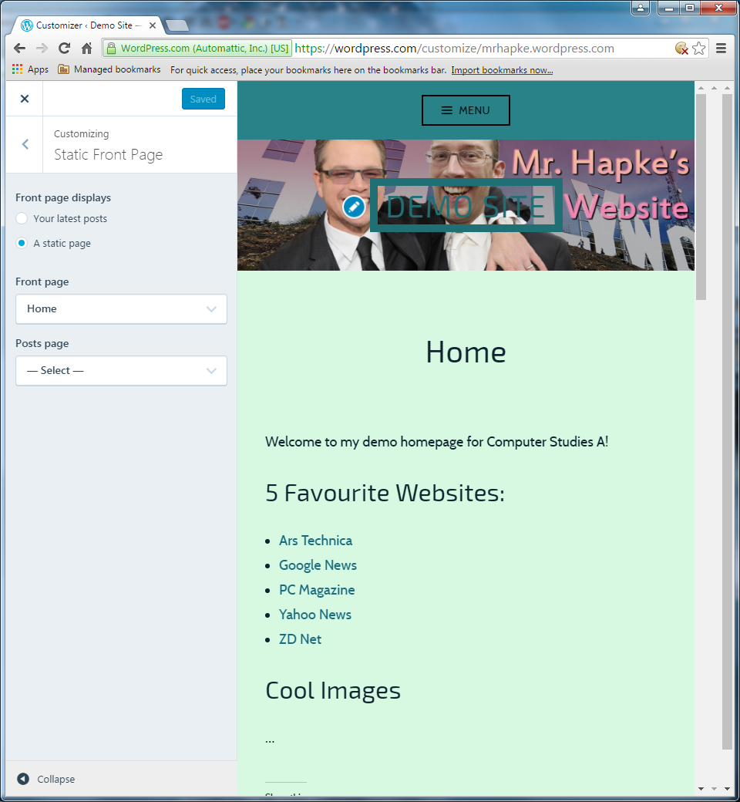

Then Save and Publish it.

Mr. Hapke’s WordPress Example Site

<https://mrhapke.wordpress.com/>