# mBlock Programming Introduction

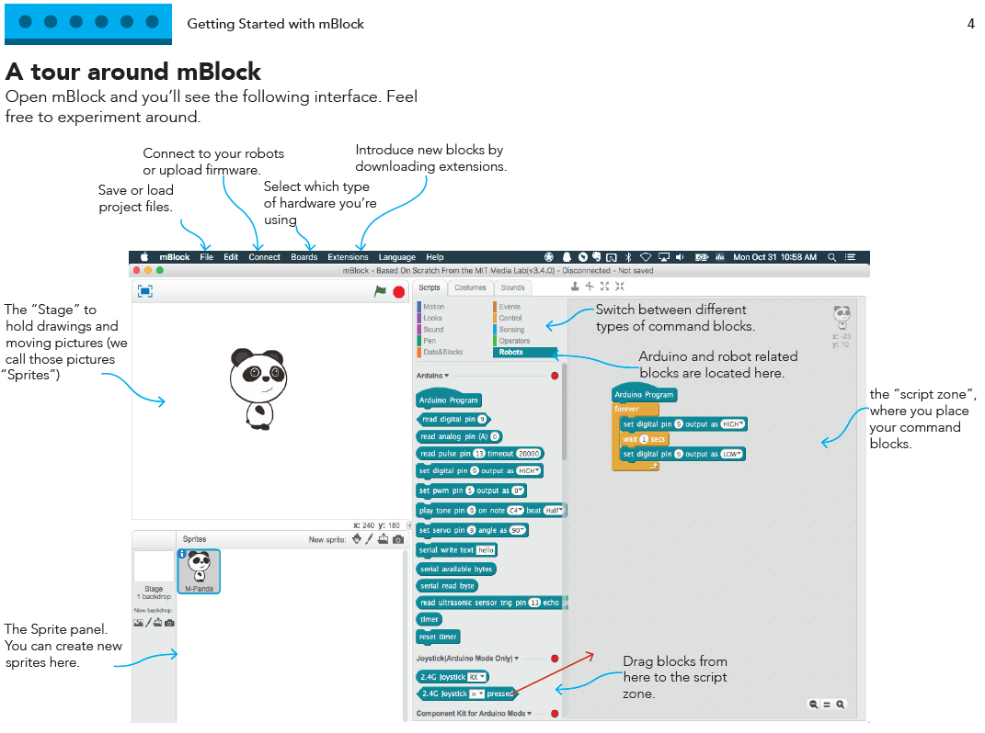

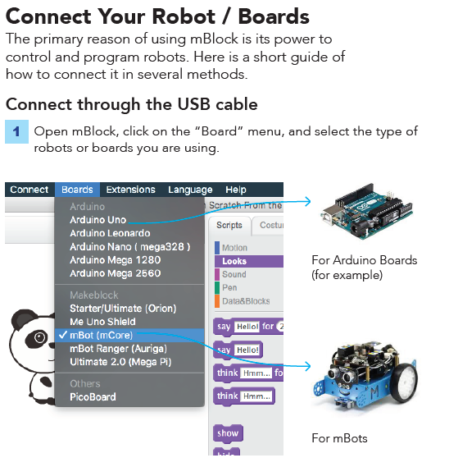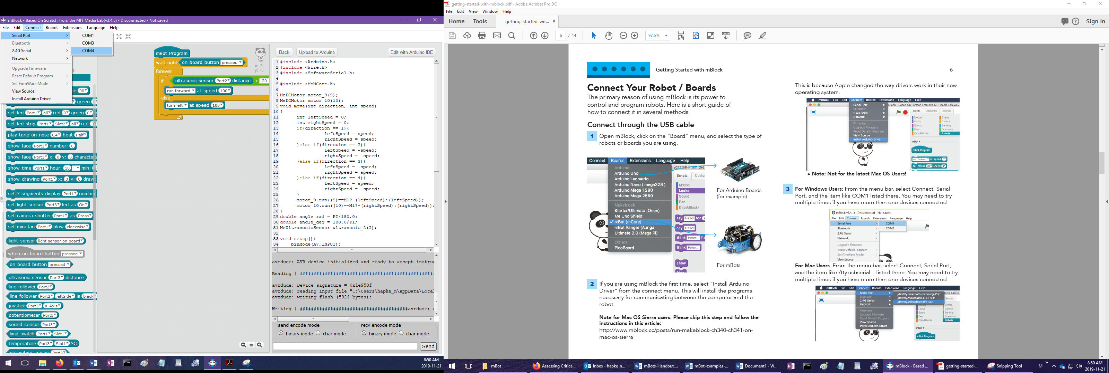

At our school, you’re looking for the last COM port. (Usually COM4, but it might be 5 or 6.)  
If you only see COM1 and COM3, that probably means you haven’t turned the mBot on.

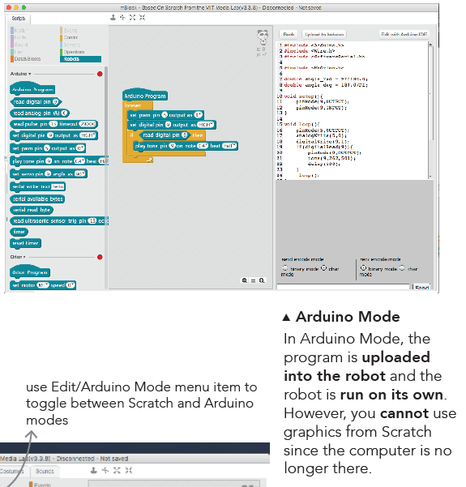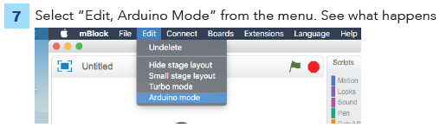

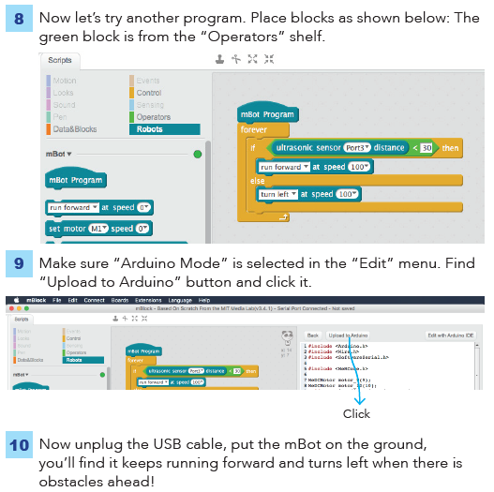

# Some programs for you to try:

**Note**: Always start your program with: 

Some of these programs are from an older PDF, with an older version of mBlock that used  to start. Use  instead.

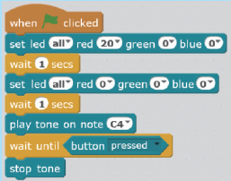

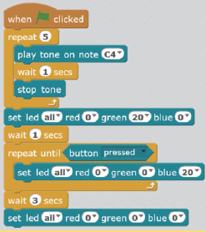

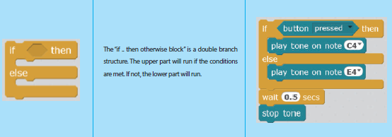

**Note**: This program takes a couple seconds to load after you turn the mBot on. Listen for the higher pitched beep, before you push the button!

