# Computers 9 :: mBots

Our overall goal is to create a Rube Goldberg Machine.

Each robot needs to accomplish the following tasks:

* Receive a message to start your program (ie: like grabbing the baton in a relay race) using the IR receiver.
* Follow a path you design and tape to the classroom floor that takes you to the next group’s robot.
* Do something cool  
  Such as:
  + Buzz a song
  + Drive a silly dance
  + Spin like a crazy robot
  + ETC ETC ETC!
* Send a message to the next robot that it’s their turn. (pass the baton along)

You will need to negotiate a code message that you will transmit/receive with the groups ahead and behind you.

I will transmit the begin message to the first group, and receive from the last group.

Here is a webpage that shows how to use the infrared transmitter & receiver: <http://www.mblock.cc/example/infrared-communication/>

# Suggested Program Design

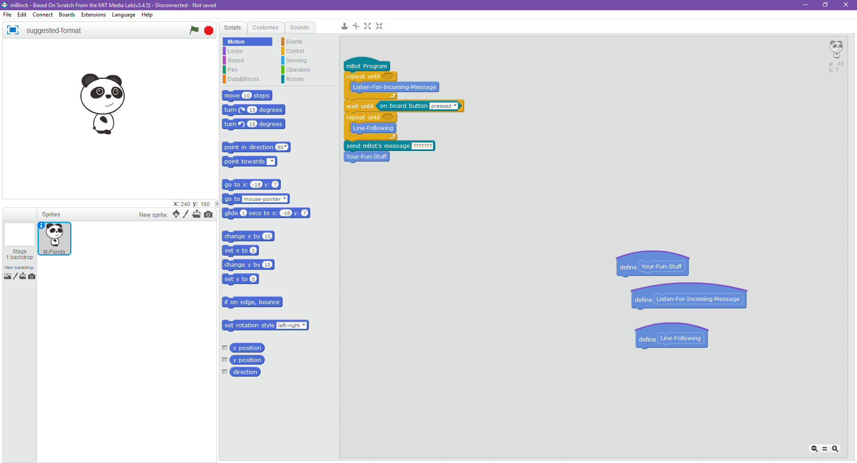

1: Your program should look something like this ☺

1. Put the robot on the start line facing the previous team
2. Wait until you receive the message from the previous team.
3. Turn on a light & make a beep so we know you received it!
4. Pick up the robot and turn it around
5. Push the button to start the line follower program
6. Drive until the Ultrasonic sensor detects the next robot
7. Pass the message on to the next team
8. Do your cool & silly move!

# Tips for Designing Your Track

* The robots light sensor don’t like the glossy floors. Make sure that you leave enough space around the edge of your crate paper.
* Don’t turn too sharp, or the robot will get confused!

# Criteria :: 5 marks each

* Design of your track
* Infrared sensor: Sending and Receiving the Baton
* How well does your robot follow the line on your track?
* How fun is your cool & silly move?
* Overall quality of your program on the PC?