Computers 9 – Computer Parts: Part A

Price out a PC build in Microsoft Excel.

I want brand new parts, not old, used, slow crap!

YOU NEED THE FOLLOWING COMPONENTS:

* Case
* Power supply
* Motherboard + CPU [Make sure they are a match! They must use the same socket/connector type.]
* RAM (Memory) [At least 8gb]
* Storage [At least 500gb]
* Keyboard
* Mouse
* Monitor

AT LEAST ONE OF THESE CUSTOMIZATIONS:

* Graphics Card
* Cool LEDs for the case
* Sound system
* Webcam

YOU MAY GET PARTS FROM ANY CANADIAN RETAILER, SUCH AS:

* Amazon.ca
* NewEgg.ca
* MemoryExpress.com

(You can mix and match, and get parts from different places)

The budget is $1500 Canadian. Including 12% tax.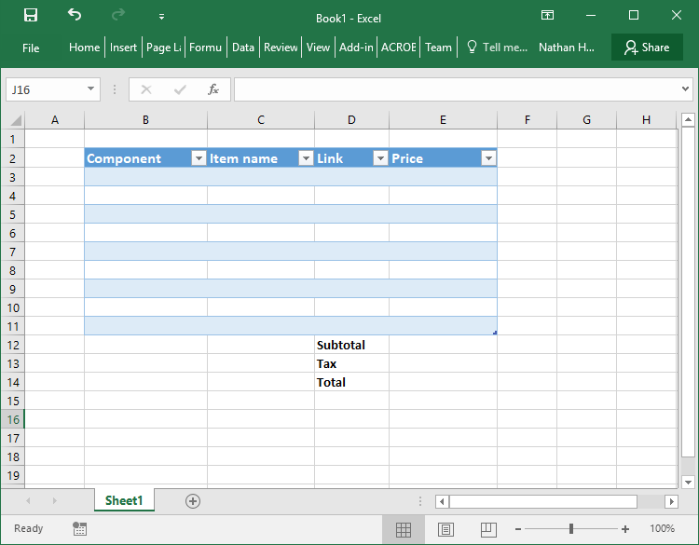

Your Excel document should have these headings:

Component – Item name – Link – Price

And that will make it look like this: