Website Banner

Make a banner for your WordPress site!

# Steps

1. Find a picture on Google Images of a Celebrity of your choice, with a friend.   
   Choose a photo where the friend is the same gender and has a similar skin tone as you.  
     
   In Google, use Tools – Size – Large.

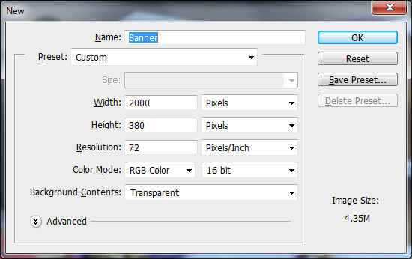

1. Check which size WordPress wants for your banner.
   1. Log in to WordPress
   2. Themes – Click Customize
   3. Header Image
   4. On my site, WordPress recommends 2000x380 pixels.   
      Make sure your width is at least 1000px.   
      Make sure your height is at least 300px.
2. Make a new Photoshop document at this size.  
   **Set the rest of the dialog box to match this perfectly:  
   Set the Width to be in Pixels first!**
3. In your My Documents / Photoshop folder, make a folder called Banner, and call the file Banner.psd
4. **Load your celebrity photo**.  
   Because the photo has been downloaded from the internet, you will need to right click on the layer and choose either: **Layer from Background**, or **Rasterize Layer** so that you can edit the picture.
5. **Take a selfie** and e-mail it to yourself, or download one from a social media site.
6. Photoshop your head onto the friend’s body
7. Add some text introducing your website
8. Change the background
9. Put an outer glow / drop shadow on something
10. Add props (eg: sunglasses, earrings, chains, fun stuff!)
11. File – Save for Web…  
    Use JPEG format.   
    Set it as your banner on your site. (See Step 1!)

# Main Criteria

**Photoshop Website Banner**

|  |  |
| --- | --- |
| Category | Criteria |
| Overall | Friend’s gender matches Name  Your head fits nicely Text introduces your page |
| Edges | Edges of selections are nicely smoothed  Use of layer masks to Reveal and Hide (not eraser!) |
| Fit with  “your” body | Fit onto neck (tilt the orientation nicely) Size is right  Skin tone matches Hair fits properly  Perspective and Lighting of your face |
| Fun stuff | Background changed  3+ Props  Outer glow / drop shadow |