Website Banner

Make a banner for your YouTube channel / Twitter feed / Website / Facebook profile / etc!

# Steps

1. Find a picture on Google Images of a Celebrity of your choice, with a friend.   
   Choose a photo where the friend is the same gender and has a similar skin tone as you.  
     
   In Google, use a size of **At Least 2MP**.  
   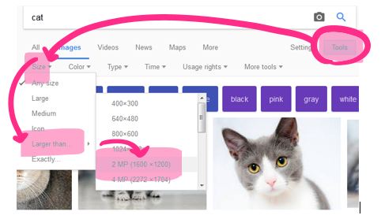
2. Make a new Photoshop document.  
   **Set it to Pixels first!**Make the size **2000x500** pixels, **96 Pixels/Inch, RGB color, 16 bit**.

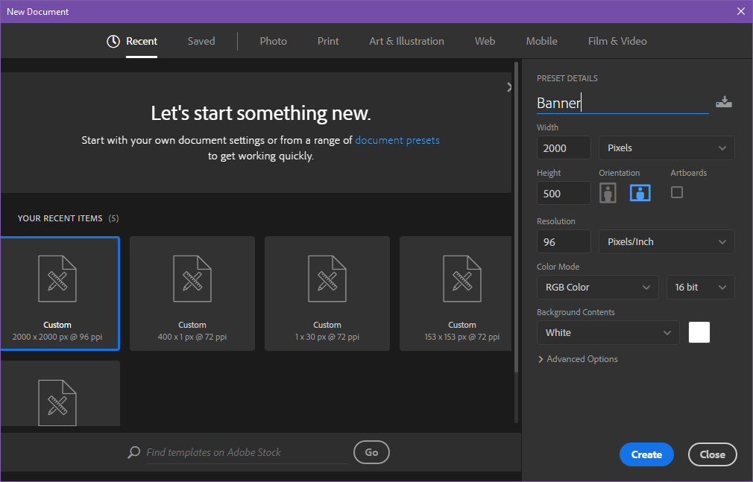

1. In your My Documents / CS10 folder, make a folder called Banner, and call the file: **[YOURNAME] Banner.psd**
2. **Load your celebrity photo**.  
   Because the photo has been downloaded from the internet, you will need to right click on the layer and choose either: **Layer from Background**, or **Rasterize Layer** so that you can edit the picture.
3. **Take a selfie** and e-mail it to yourself, or download one from a social media site.
4. Photoshop your head onto the friend’s body
5. Add some text introducing your website
6. Change the background
7. Put an outer glow / drop shadow on something
8. Add props (eg: sunglasses, earrings, chains, fun stuff!)

# Rubric Draft (Subject to Change)

**Photoshop Website Banner** Name: Total: ___ / 20

|  |  |  |  |  |  |  |
| --- | --- | --- | --- | --- | --- | --- |
| Category | Criteria | 0 | 2 | 3 | 4 | 5 |
| Overall | Friend’s gender matches Name & Period #  Your head fits nicely Text introduces your page |  |  |  |  |  |
| Edges | Edges of selections are nicely smoothed  Use of layer masks to Reveal and Hide (ie: use the magic wand) |  |  |  |  |  |
| Your head | Fit onto neck (tilt the orientation nicely) Size is right  Skin tone matches Hair fits properly |  |  |  |  |  |
| Fun stuff | Background changed  3+ Props  Outer glow / drop shadow |  |  |  |  |  |