Podcasting: Technology Topic

Find a news article on the internet that you like, and has a technology element to it. Choose groups of 2 or 3. Make 2 minutes of content per person.

# Some Sites to Find Articles on

Find at least 2 articles on the same subject/event.

Here are some sites to try:

|  |  |
| --- | --- |
| * [Ars Technica](https://arstechnica.com/) | * [Tech Crunch](https://techcrunch.com/) |
| * [Live Science](https://www.livescience.com/) | * [Google News](https://news.google.com) |
| * [Y-Combinator News](https://news.ycombinator.com/) | * [Engadget](https://www.engadget.com/) |
| * [Gizmodo](https://gizmodo.com/) |  |

# Episode Flow

1. Introduction requires: podcast name, the episode topic, plug your sponsor (work in their tag line!), who is speaking?
2. Lead the listener into the topic with some background information. Give the listener a feel for who the important people are.
3. Main content.
   1. Who does this effect?
   2. Why is this interesting? Why does it matter?
   3. Why does it matter to society?
   4. What could happen next? Make a prediction/warning for the future.
4. Wrap up: thank the listeners, plug a different sponsor

# Choose a Format

|  |  |
| --- | --- |
| * Interview an expert/key person (you can impersonate them) | * Story telling |
| * Pose a challenge to one of the group members | * News program |
| * Call in program | * Other? |

# Sound Effect Sites

Give your episode at least 3 sound effects / background music. You could use an effect as a break between an ad and the content, or for the intro jingle, etc.

Here are some sites to try:

* <https://freesound.org/>
* <https://www.zapsplat.com/>
* <http://www.grsites.com/archive/sounds/>

If you have some good sound effect sites, let me know, and I’ll add them to this list ☺

# Writing The Script

We are going to use Word Online to write the script, so that every group member can have access to the script. That way we can edit it together, and if one person is missing, the rest of the group can keep working! ☺

## Logging in to Office 365 (Word Online)

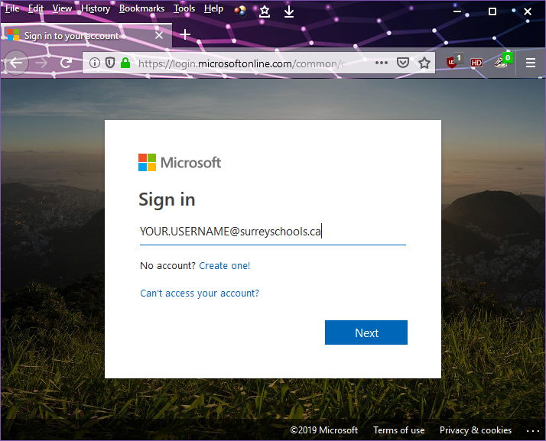

1. Go to office.com  
   Your username is: [YOUR.USERNAME]@surreyschools.ca  
   Your school account is already linked to Microsoft!

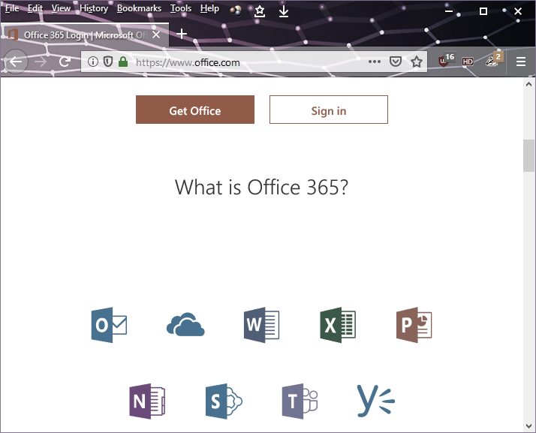

When you open it from here at school, you might not need to type in your password. If you log in from home, it will send you to the Surrey Schools login page for you to type in your password. That’s normal.

1. Choose Word Online

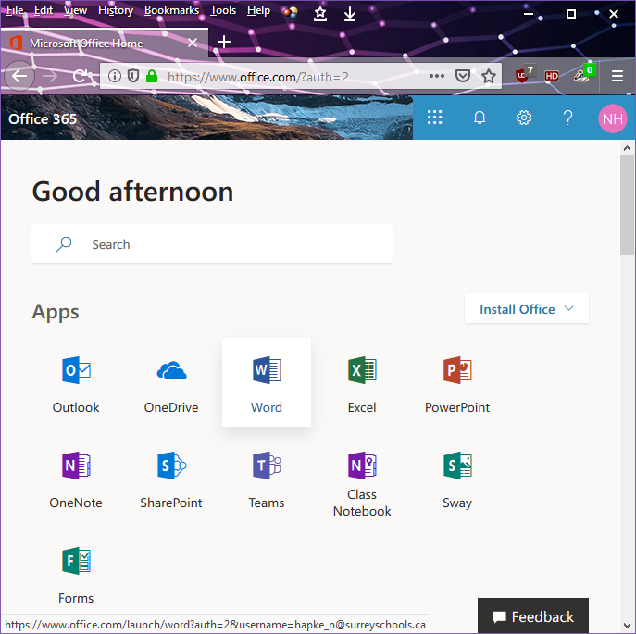

## One Person Creates the Document

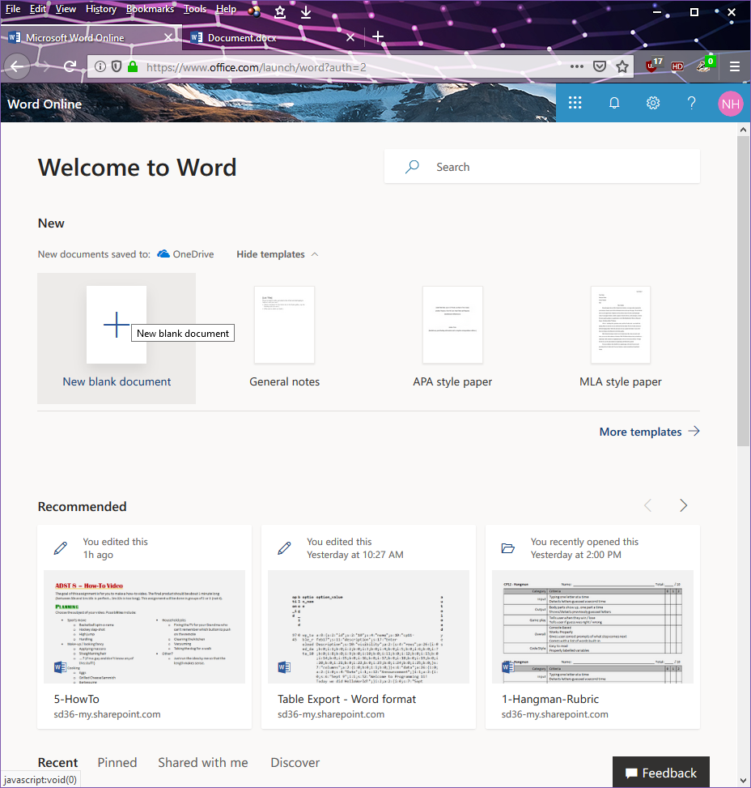

1. Create a New Blank Document
2. Name your file (like using Save As) by clicking on “**Document**” at the top.

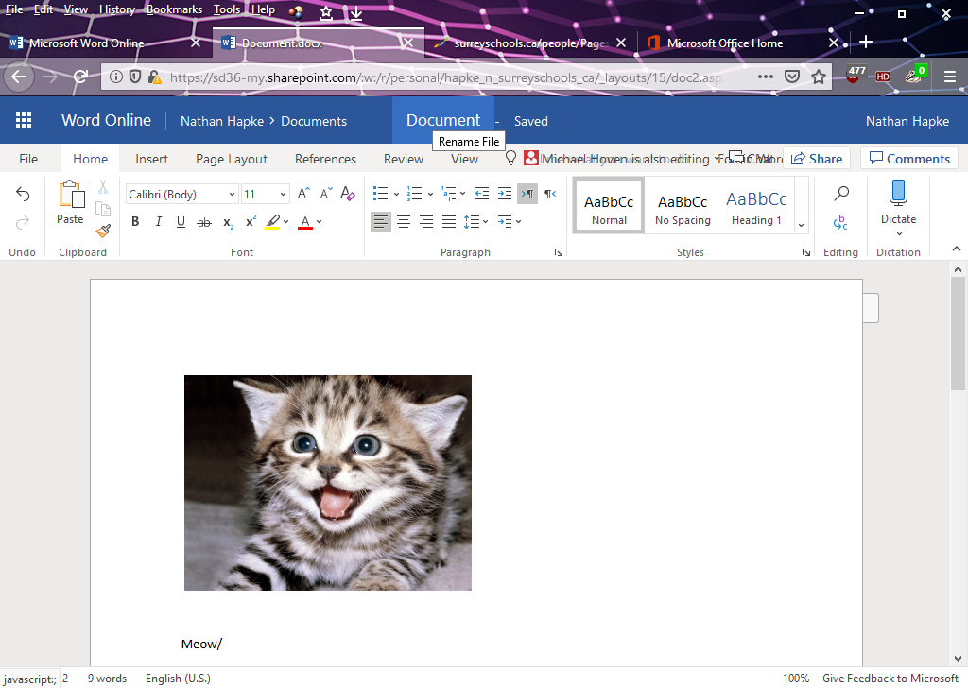

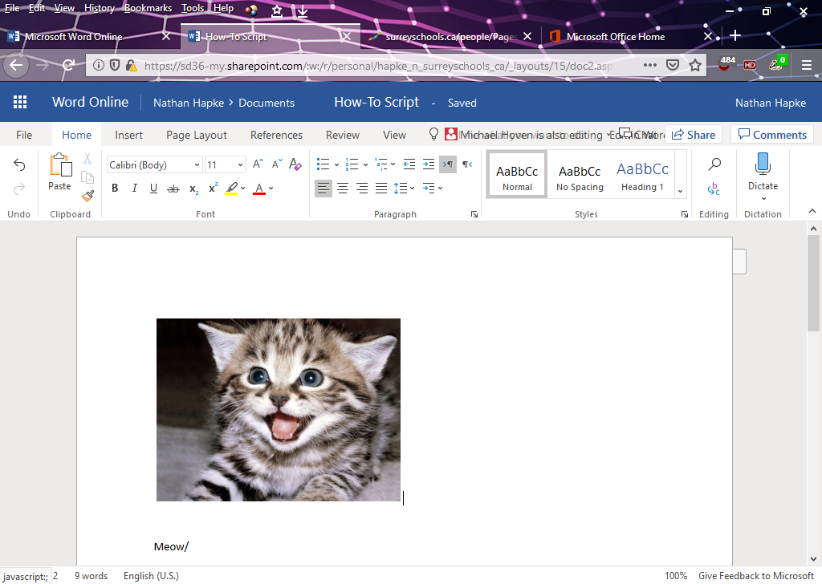

1. At the top right, click the **Share** button.

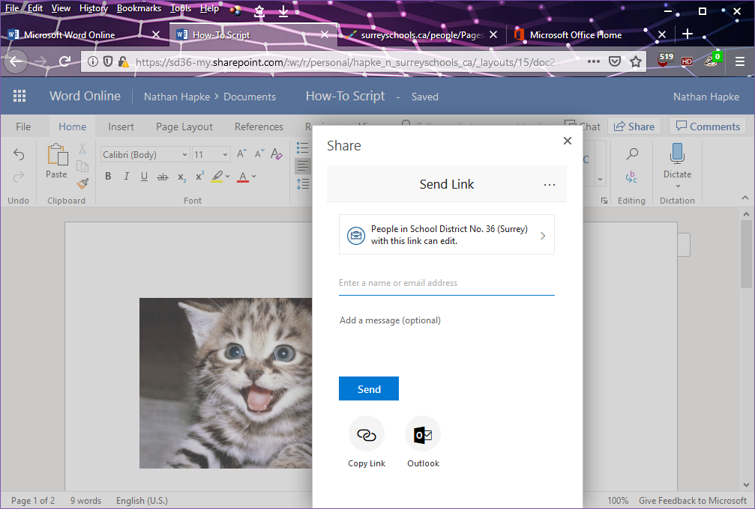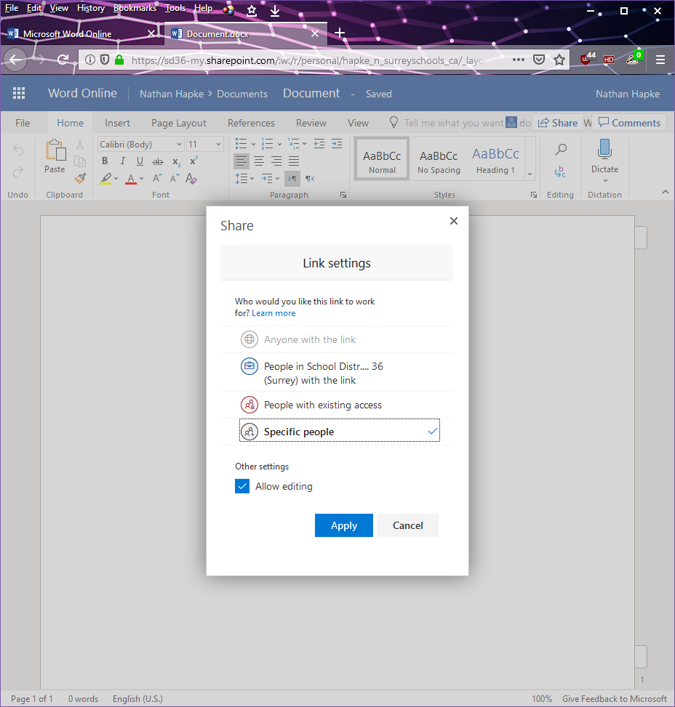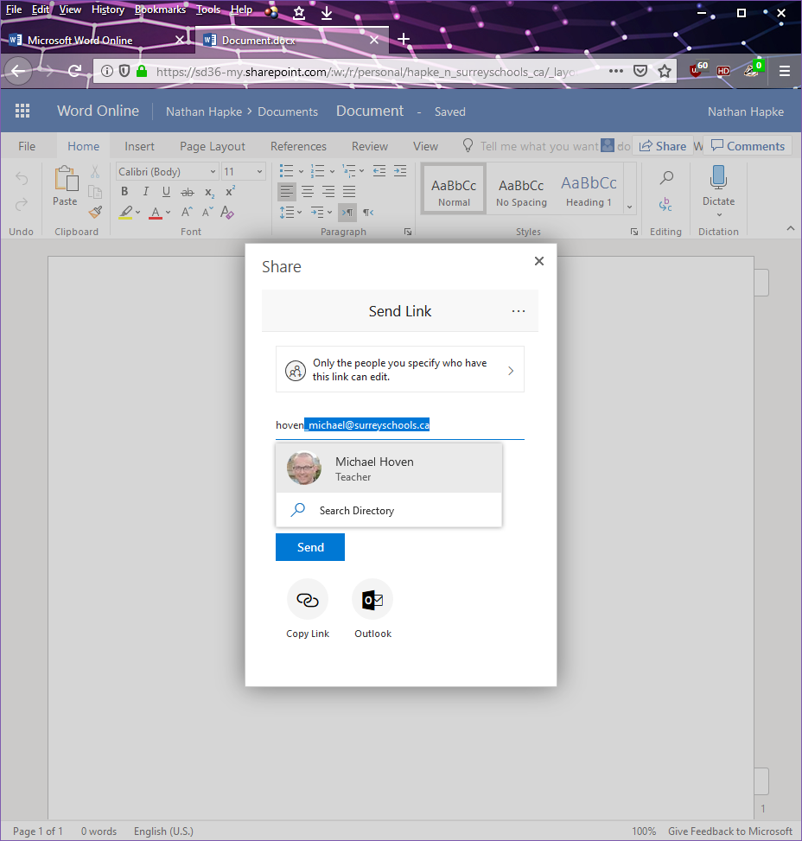

1. We don’t want everyone in the school district to be able to edit our script!  
   Change the permission from **School District #36 (Surrey)** to **Specific People**Make sure **Allow Editing** is checked. We want our group members to be able to make edits!
2. Type in your first group member’s last name.   
   If your group member doesn’t pop up right away, click the **Search Directory** button.  
   **Find your group member, and click on them.**   
   Repeat this step for your 3rd group member.
3. Click Send.

## After it has been shared

If you are one of the other group members, here’s how to find the file that was shared with you.   
Log in to Word Online using Step 1 and 2 from above.

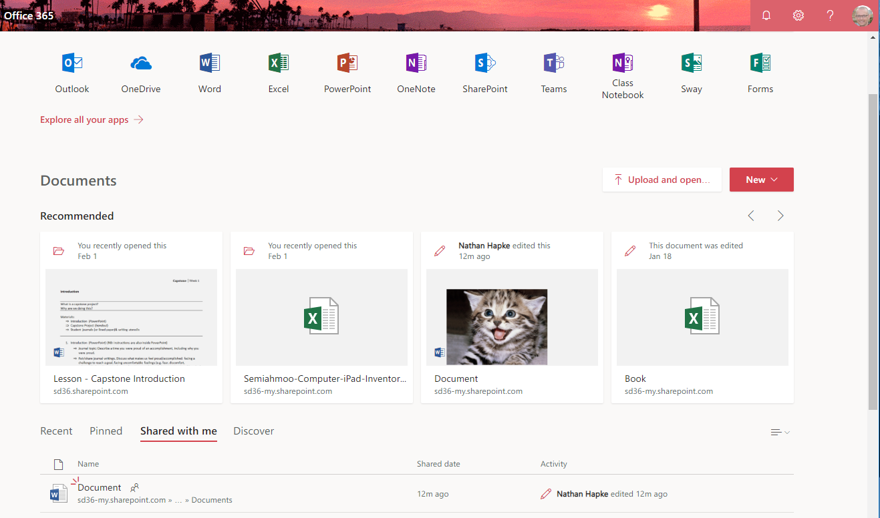

**Notice**: Mr. Hoven’s account!



**Notice**: Mr. Hapke’s shared file!

1. Find the **Shared with me** tab. Click on it.
2. Find the File in the list below.