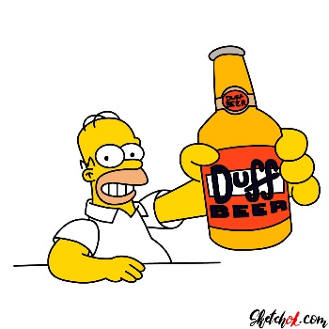**Animation**

In this assignment, we will animate a small scene.

You can use the head(s) of some real characters/animals/people etc, but I would like you to draw the bodies/rest.

Your scene should have 2+ characters.

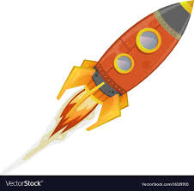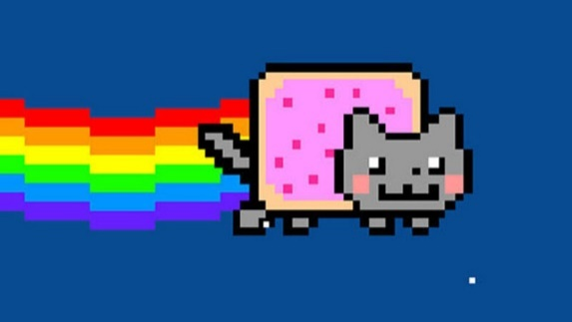Your background should have at least a couple elements.

The length should be at least 10 seconds.

You must use a Path and Tweens.